**TASK 10 – Launch an instance using Yellow Circle Cloud.**

**AIM :** To Create and launch Windows Server virtual machine using Yellow Circle Cloud Platform.

**DESCRIPTION :**

Yellow Circle provides avirtual information technology platform allowing students to learn about the unique capabilities of cloud computing and cloud infrastructure. Yellow Circle’s ultimate mission is to provide a platform for building the foundation for our future IT workforce to produce sustainable, equitable IT solutions to a variety of global technology challenges.

In this experiment we will learn how to launch an instance and run using yellow circle.

**PROCEDURE :**

1. First go to [www.yellowcircle.net](http://www.yellowcircle.net) and signup for a free student account.

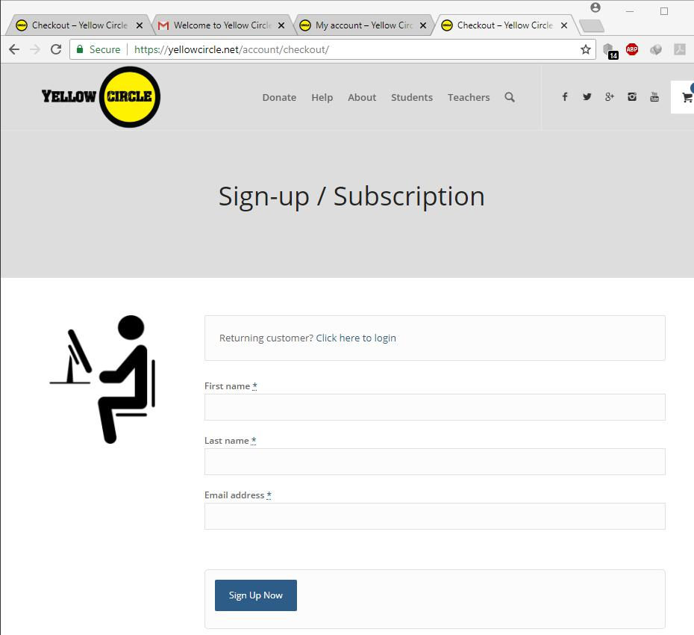

After signup you will get a mail with the login id and a password to login to your yellow circle account.

After logging in the dash board looks as follows :

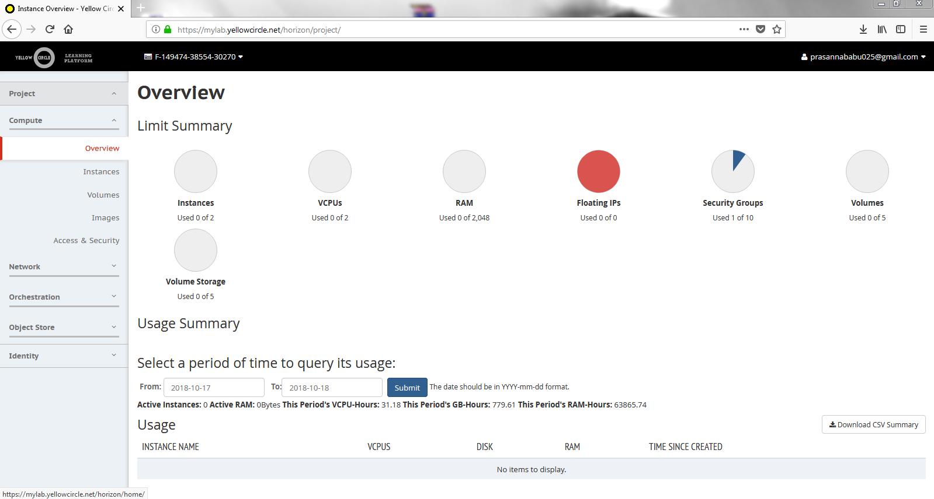

2. Click on the Instances from the Compute menu located at the left side .

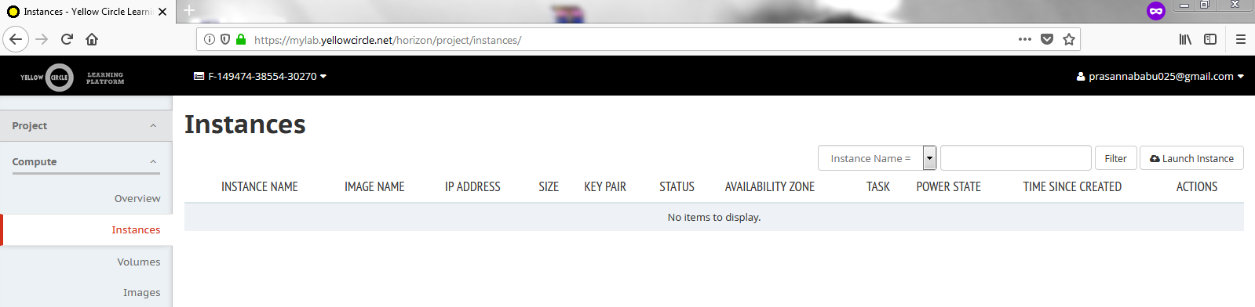

3. Now Click on the Launch instance

Enter the name of the Instance

This is how the window looks like .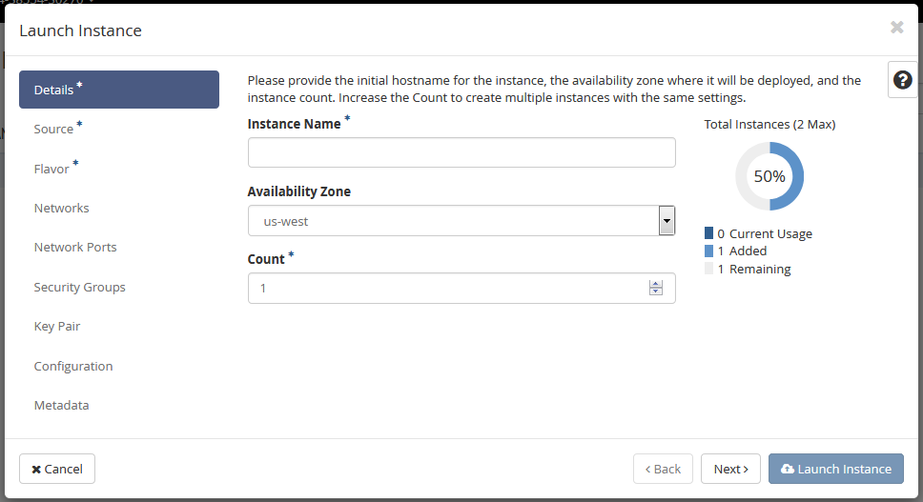

Click Next , you will be prompted to another window which shows the available instance sources.

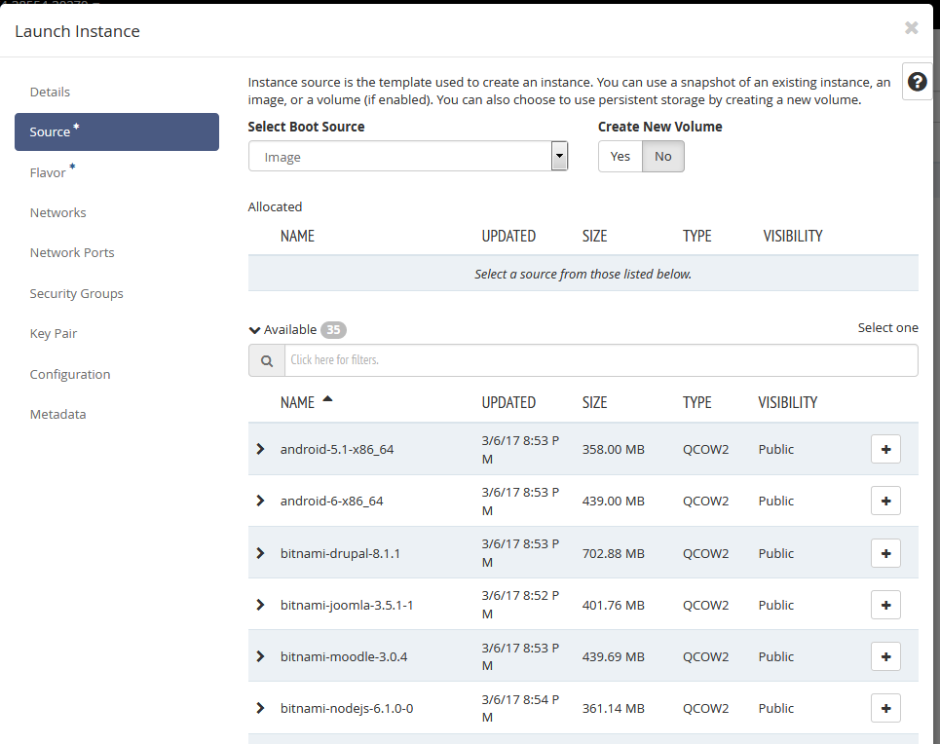

4.Now select the windows-server-2008-r2-std by clicking the + button and click Next .

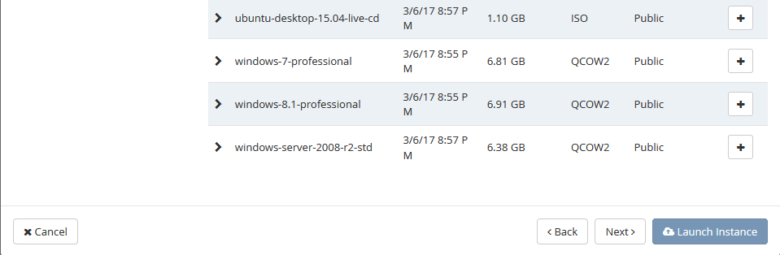

The window looks like this after selecting an instance.

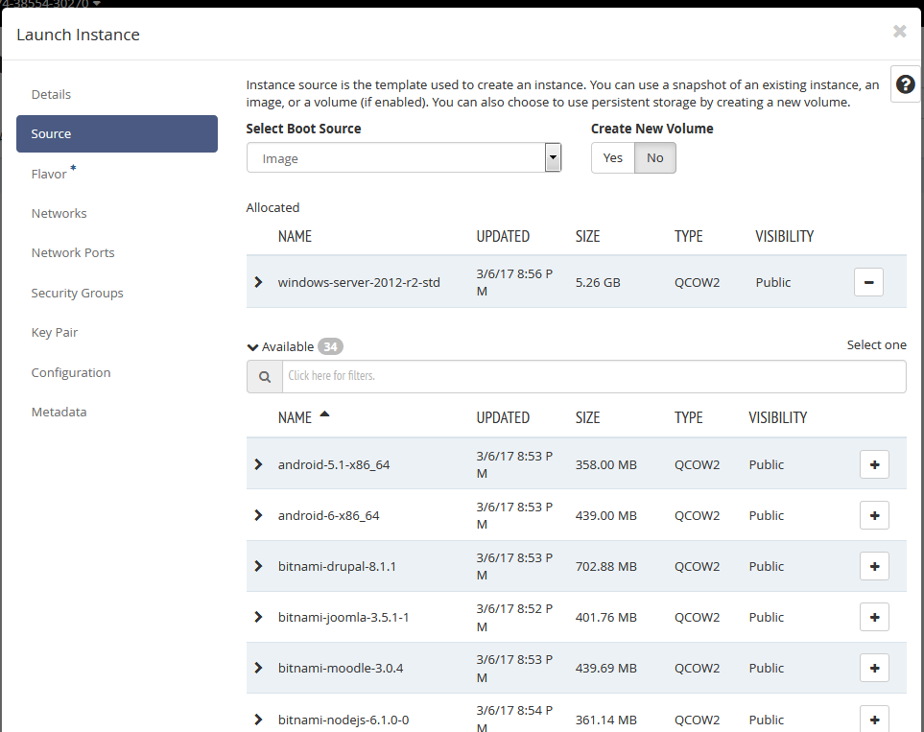

5. Now select and click Flavor at the left menu , select lab.medium and click next.

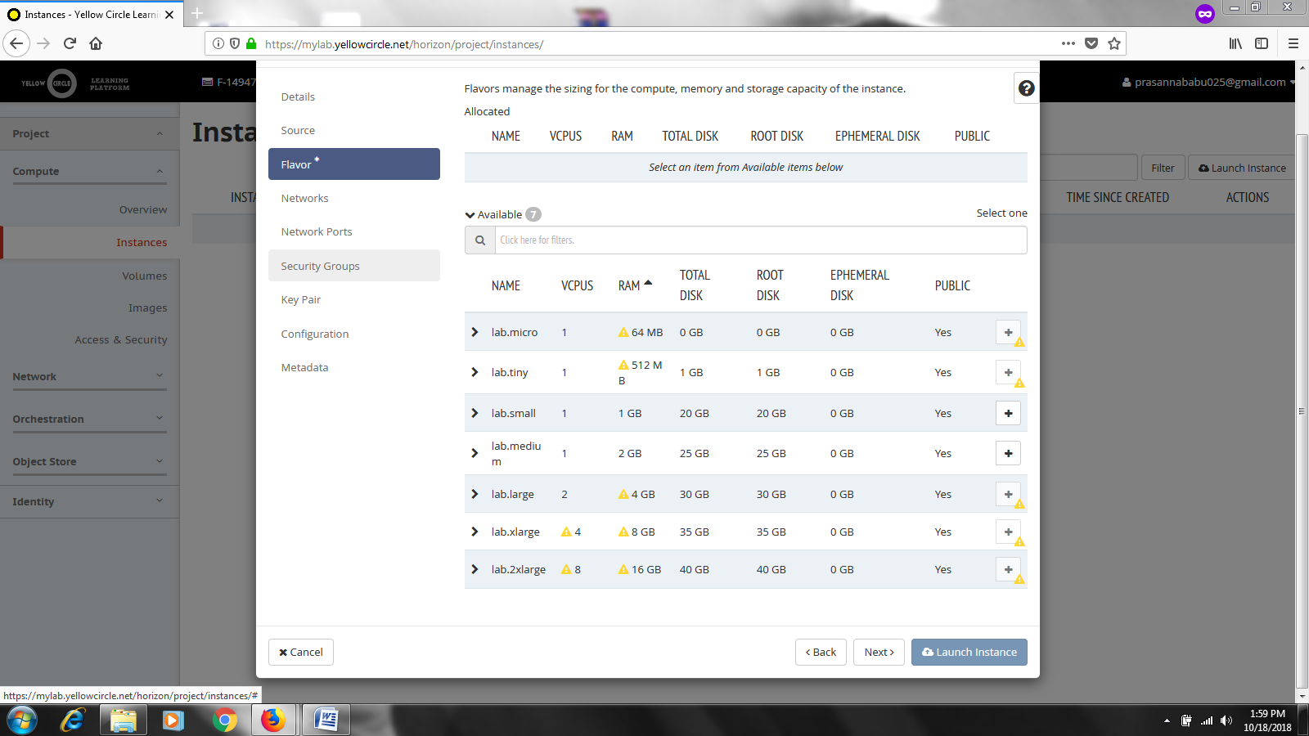

The window looks as follows after selecting the lab.medium flavor.

6.Click Launch Instance.

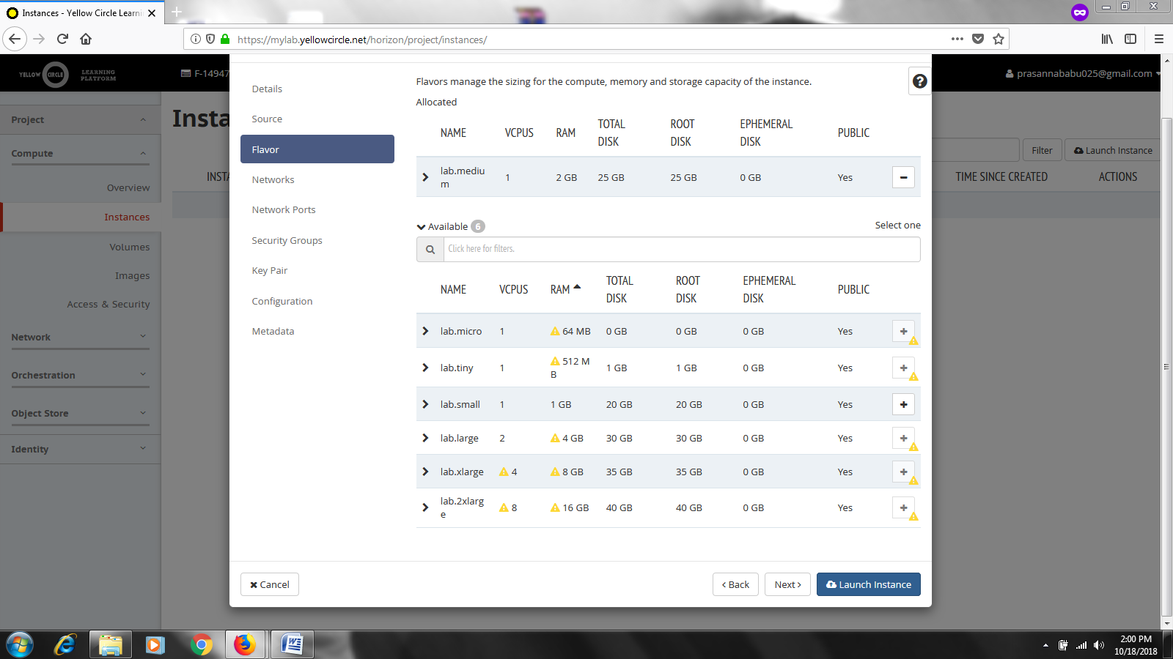

Now Your instance will begin to spawn as shown below.

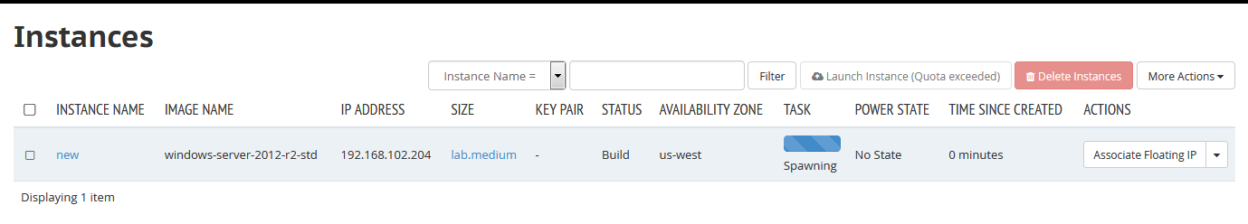

Within a few moments your instance will be ready. It will stop being orange, the status will be Active and the Power state will be in Running mode

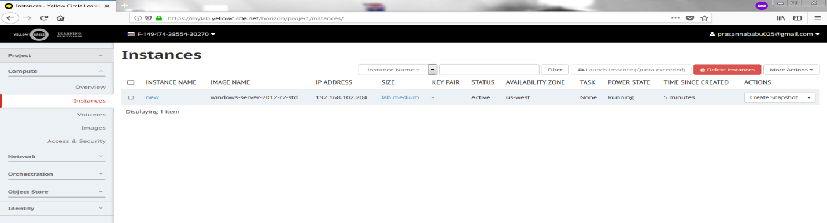

7.Click on the Name of your instance and select Console to start the windows machine

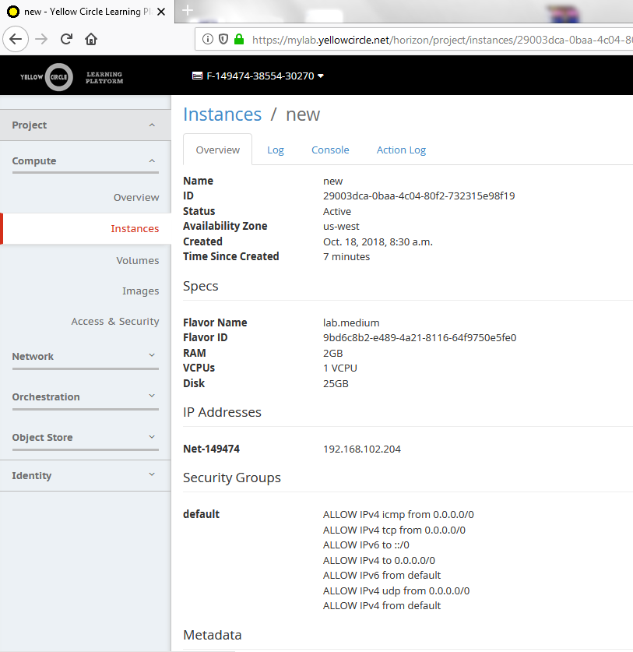

We get the following screen, Click next and set the password to run the windows machine.

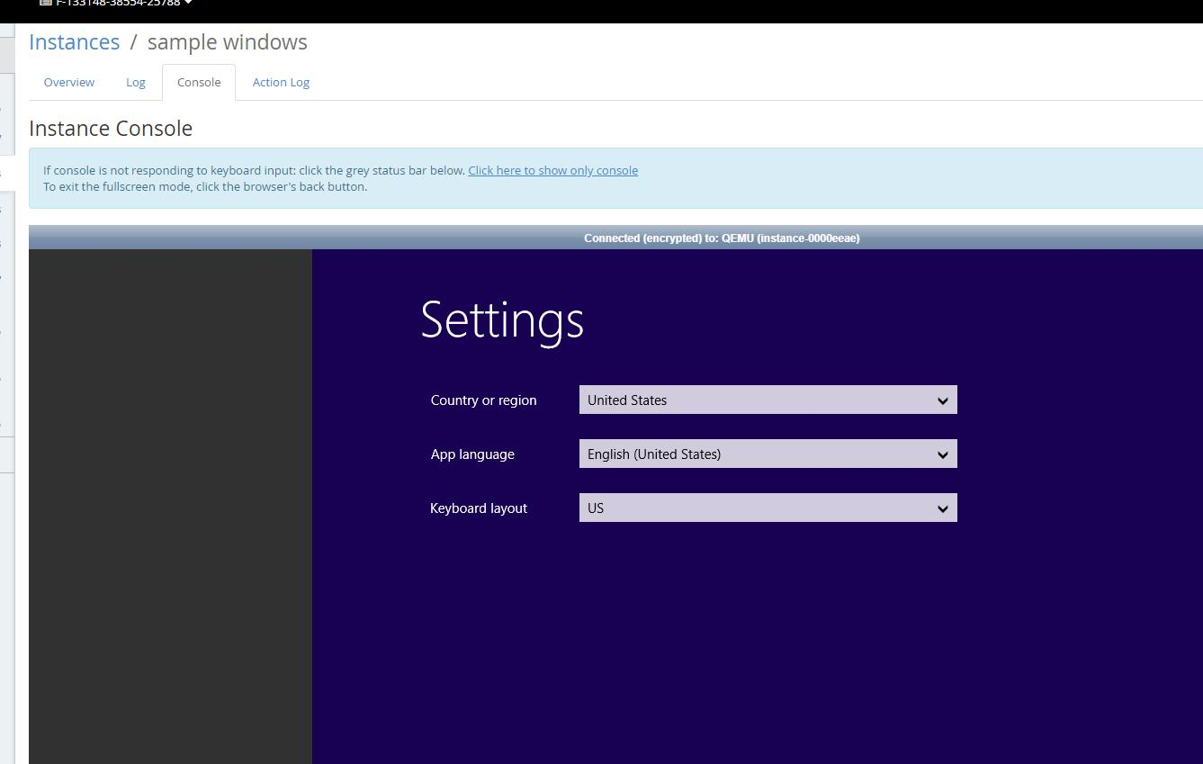

Thus Windows machine is ready .

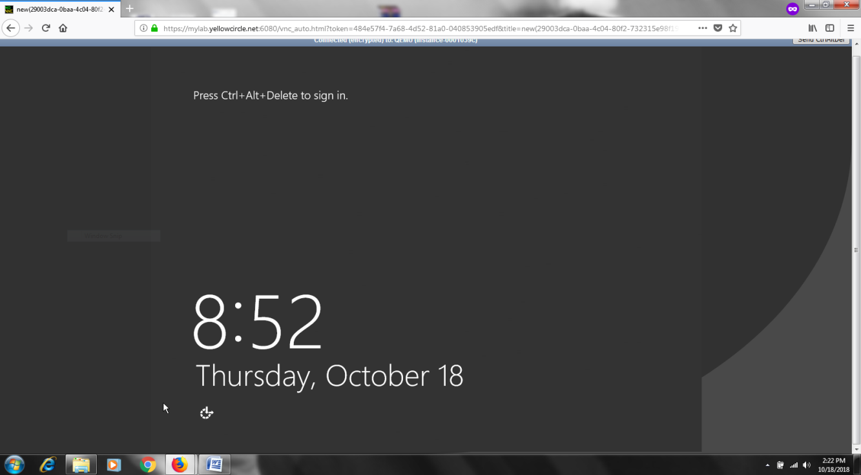

**RESULT :** Hence the creation and launching of an instance (Windows server ) using Yellow circle completed successfully.